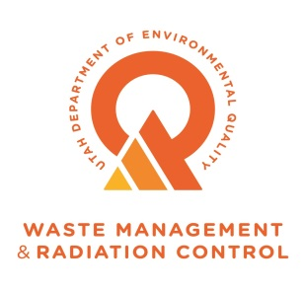

Division of Waste Management and Radiation Control

USED OIL PROCESSOR PERMIT

Permittee Name: | Knight Brothers, L.L.C. dba Intermountain Rigging and Heavyhaul (IRH)
Permittee Mailing Address: | P.O. Box 27163  Salt Lake City, Utah 84127-0163
Permittee Phone Number: | (801) 972-5581
Permittee Contact: | Heather NayAsset Recovery Coordinator  (801) 478-4755 (Office)  (385) 235-4832 (Cell)  Email: Heather@irhusa.com
Facility Address: | 850 South 4340 West  Salt Lake City, Utah 84104
Facility Contact: | Chris Johnson – Operations Manager  (801) 910-7162 (cell)  Email: chris@irhusa.com
Type of Permit: | Used Oil Processor Permit
Permit #: | UOP-0157
Original Issue Date: | December 30, 2015
EPA ID #: | UTR000001685
Signature: ___________________________ Date: _____________________
Ty L. Howard, Director
Division of Waste Management and Radiation Control
I.A. Effect of Permit

I.A.1. Intermountain Rigging and Heavyhaul (hereafter referred to as “Permittee”) is hereby authorized to operate as a used oil processor in accordance with all applicable requirements of R315-15 of the Utah Administrative Code and of the Used Oil Management Act (the Act) 19-6-701 et. Seq., Utah Code Annotated and this Permit.
I.A.2. This permit shall be effective for a term not to exceed ten years in accordance with the requirements of R315-15-15 of the Utah Administrative Code. This permit shall be reviewed by the Director five years after the Permit’s effective date of issuance or when the Director determines that the Permit requires review.

I.A.3. Attachments incorporated by reference are enforceable conditions of this Permit, as are documents incorporated by reference into the attachments. Language in Section I and II supersedes any conflicting language in the attachments or documents incorporated into the attachments.
I.B. Permit Revocation
I.B.1. Violation of any permit condition or failure to comply with any provision of the applicable statutes and rules shall be grounds for enforcement actions, including revocation of this Permit. The Director shall notify the Permittee in writing of his intent to revoke this Permit.
I.B.2. It shall not constitute a defense for the Permittee in an enforcement action that it would have been necessary to halt or reduce the Permittee’s business activity in order to maintain compliance with the conditions of this Permit and its attachments.

I.C. Permit Modification
I.C.1. The Permittee may request modifications to any item or operational activity covered by this Permit by submitting a written permit modification request to the Director. If the Director determines the modification request is substantive, a public hearing, a 15-day public comment period or both may be required before issuances of a decision by the Director on the modification request. Implementing a modification prior to the Director’s written approval constitutes a violation of this Permit and may be grounds for enforcement action or permit revocation.
I.C.2. Changes in operational activities include any expansion of the facility beyond the areas designated, alteration of processing operational parameters, changes in the type or number of storage tanks, piping, other processing equipment and changes to the contingency plan. The Director may require the Permittee to submit additional information when reviewing permit modification requests to ensure the safe handling of used oil at the processing facility in accordance with 19-6-710 (3)(b)(xii) of the Utah Administrative Code.
I.C.3. The Director may modify this Permit as necessary to protect human health and the environment or because of statutory or regulatory changes.

I.C.4. The Permittee shall notify the Director, in writing, of any non-substantive changes, such as changes in the contact person, within 20 days of the change.

I.D. Facility Maintenance and Emergency Equipment
I.D.1. The Permittee shall maintain and operate the Processor Facility to minimize the possibility of fire, explosion or sudden or non-sudden release of used oil to air, ground, soil, surface and groundwater and sewer systems that could threaten human health and the environment.
I.D.2. The Permittee shall have communication systems, fire alarms and fire suppression equipment, and processing alarms in place and operational at the facility, as well as arrangements with local emergency response teams (e.g., fire, police, and hospital) in accordance with R315-15-5.3 of the Utah Administrative Code.
I.D.3. The Permittee shall have written documentation of the inspection and maintenance of used oil processing equipment, containers, tanks, fire suppression systems (portable and fixed) and testing of emergency alarms for fire and other operational alarms set for processing equipment. The Permittee shall determine, document in writing and adhere to the scheduled frequency for inspections, maintenance and alarm testing to ensure safe operation as specified in Attachment 1.
I.D.4. To prevent access by unauthorized persons or vehicles during hours when the facility is closed and authorized personnel are not present, the Permittee shall secure the facility, lock the entrance security gate and maintain adequate perimeter fencing.
I.D.5. The Permittee shall maintain a diagram with the location of emergency spill kits and fire extinguishers (Attachment 1-Figure 1).

I.E. Spills and Contingency Plan
I.E.1. The Permittee shall take all reasonable steps to minimize releases to the environment and shall carry out such measures as are necessary to protect human health and the environment. In the event of a release of used oil, the Permittee shall immediately take appropriate actions to comply with R315-15-9 of the Utah Administrative Code and this Permit (Attachment 2), Emergency Control and Contingency Plan.
I.E.2. A secondary containment system for used oil process and storage tanks, piping and ancillary equipment shall be constructed and maintained for the facility in accordance with R315-15-5.5(c) of the Utah Administrative Code. The joints between the concrete floor and the tank pads shall be sealed to prevent migration of oil to the soil and groundwater.
I.E.3. Used oil, water or other liquids that may accumulate in the secondary containment system or any ancillary facility sumps shall be removed within 24 hours of discovery to prevent the possible migration to soil, ground or surface waters.
I.E.4. The Permittee shall document the inspections of the secondary containment system in accordance with Attachment 1. Inspection documents shall include inspector’s name, date, areas inspected, any problems found, and the subsequent actions taken by the facility to maintain system integrity.
I.E.5. The Permittee shall notify the Utah Department of Environmental Quality 24-hour Answering Service, (801) 536-4123, for used oil releases exceeding 25 gallons or for smaller releases that pose a potential threat to human health or the environment in accordance with R315-15-9 of the Utah Administrative Code.
I.E.6. In accordance with R315-15-9.4 of the Utah Administrative Code, the Permittee shall submit to the Director a written report within 15 days of any reportable release of used oil.
I.E.7. All information required by R315-15-9.4 of the Utah Administrative Code shall be included in the report. The report shall also include a description of actions taken by the Permittee to prevent future spills.
I.E.8. The Permittee shall document and maintain analytical and disposal records for a minimum of three years. The Permittee shall also characterize waste generated during the spill cleanup to determine if the waste is hazardous or non-hazardous in accordance with R315-15-8 of the Utah Administrative Code.
I.E.9. The Permittee shall notify the Director within 24 hours when the used oil stored in tanks (including ancillary equipment) and containers has PCB concentrations greater than or equal to 50 parts per million (ppm).
I.F. Records
I.F.1. Retention
I.F.1.a. The Permittee shall maintain all used oil records required by R315-15 of the Utah Administrative Code and this Permit at the Permittee’s Processor facility located at located at 850 South and 4340 West in Salt Lake City, Utah. Records may be in hard copy or in an electronic format and shall be readily accessible for inspection by authorized representatives of the Director. The Permittee shall maintain, for a minimum of three years, all applicable used oil processor associated records required by R315-15 of the Utah Administrative Code and this Permit, with the exception of the operating record, which shall be kept until facility closure.
I.F.2. Operating Record
I.F.2.a. The Permittee shall maintain an operating record (paper or electronic) until final closure of the facility. The operating record shall include the following:
I.F.2.a.i. The name of the processing facility operator, the processing operations (description and time), any upset condition (e.g., alarms, mechanical failure, or any event that requires implementation of the facility’s Contingency Plan).
I.F.2.a.ii. The amount of used oil placed into or removed from each tank, the source of the used oil (e.g. transformer identification number and date of disassembly), tank maintenance and inspection, and tank decontamination records.
I.F.2.a.iii. Daily volume of oily water processed through the system, including any wastewater discharge records.
I.F.3. Tracking Records
I.F.3.a. Tracking records shall document the volume of used oil received by the facility from used oil transporters and the volume of used oil shipped from the facility and the name of the facility where the used oil was shipped for recycling or disposal.
I.F.3.b. Tracking records shall include information required by R315-15-5.7 of the Utah Administrative Code in the form of shipping documents such as bill of ladings, manifests, invoices or other applicable transportation documents generated by the Permittee or other used oil transporters.
I.F.3.c. The Permittee shall only accept used oil from or deliver used oil to a transporter that has a current Used Oil Transporter Permit issued by the Director.

I.G. Sampling and Analysis Plan

I.G.1. The Permittee shall follow all sampling and analytical procedures in Section II.E through II.F, Used Oil Sampling and Analytical Procedures, when conducting used oil sampling and analytical testing to meet the requirements of R315-15 of the Utah Administrative Code and this Permit.
I.G.2. The Permittee shall have laboratory analytical data, that documents the PCB concentration of used dielectric mineral oil drained from electrical transformers and other electrical equipment, regulated under 40 CFR § 761, prior to acceptance and placement in the facilities used oil storage tanks, containers or processing equipment.

I.H. Prohibitions
I.H.1. The Permittee shall not manage used oil in surface impoundments or waste piles unless the units are subject to regulation under R315-7 or R315-8 of the Utah Administrative Code.
I.H.2. Used oil shall not be placed, discarded or otherwise disposed of in any solid waste disposal facility operated by a political subdivision or a private entity or in sewers, drainage systems, septic tanks, surface or ground waters, watercourses or on the ground.
I.H.3. The Permittee shall not place, manage, discard or otherwise dispose of used oil in any manner specified in R315-15-1.3 of the Utah Administrative Code.
I.H.4. Used oil that has been mixed with hazardous waste as defined by R315-1 and R315-2 of the Utah Administrative Code or PCBs as defined by R315-301-2(53) of the Utah Administrative Code shall no longer be managed as used oil and shall be subject to applicable hazardous waste and PCB-contaminated waste rules.
I.H.5. Used oil shall not be stored in tanks, containers or piping that have previously stored hazardous waste, unless the tanks, containers and piping are emptied as described in R315-2-7 of the Utah Administrative Code prior to storing or transferring used oil.
I.H.6. The Permittee shall not accept used oil for processing with a PCB concentration greater than or equal to 50 mg/kg (ppm).
I.H.7. The Permittee shall manage used oil with PCB concentrations of greater than or equal to 2 mg/kg but less than 50 mg/kg in accordance with R315-15-18 of the Utah Administrative Code. Used oil shall not be diluted to avoid any provision of any Federal or State environmental regulation.
I.H.8. Used oil shall not be stored in tanks, containers or piping that have previously stored PCB contaminated materials at or above 50 mg/kg (ppm), unless the tanks, containers and piping or storage units are decontaminated as described in 40 CFR 761 Subpart S prior to storing or transferring used oil. Any used oil that was mixed with the PCB-contaminated material shall be managed in accordance with R315-15-18 of the Utah Administrative Code and 40 CFR 761 Subpart S, as applicable.

I.I. Waste Management

I.I.1. The Permittee shall determine through characterization, before disposal, if used oil or solid waste generated from spills or operational activities is hazardous or non-hazardous waste.
I.I.2. The Permittee shall document and maintain records showing proper characterization, handling and disposal for all used oil related waste, including oily wastewater if sent for disposal.
I.I.3. The Permittee may dispose of non-hazardous used oils in accordance with R315-15-1.3 and R315-15-8.2(b) of the Utah Administrative Code.
I.I.4. The Permittee shall not utilize used oil as a dust suppressant, weed suppressant, for road oiling or for other similar uses that have the potential to release used oil into the environment.
I.I.5. The Permittee shall properly characterization and dispose of wastes in accordance with R315 of the Utah Administrative Code.
I.J. Liability and Financial Assurance Requirements
I.J.1. The Permittee shall be financially responsible for cleanup and closure costs, general liabilities and environmental pollution legal liability for bodily or property damage to third parties resulting from sudden release of use oil in accordance with R315-15-10 through 12 of the Utah Administrative Code and this Permit.
I.J.2. The Permittee shall provide documentation of financial responsibility, environmental pollution legal liability and general liability coverage annually to the Director for review and approval by March 1 of each reporting year or upon request by the Director.

I.J.3. The Permittee shall receive written approval from the Director for any changes in the extent, type (e.g., mechanism, insurance carrier, or financial institution), or amount of the environmental pollution legal liability or financial assurance mechanism for coverage of physical or operational conditions at the facility that change the nature and extent of cleanup and closure costs. The Permittee shall receive approval from the Director prior to implementation of changes.
I.K. Cleanup and Closure Plan
I.K.1. The Permittee shall ensure that the closure cost estimates in Attachment 3 are sufficient to remove all used oil, used oil residues and to remediate any releases of contaminants to surface waters, groundwater and soils.
I.K.2. The Permittee shall update its closure cost estimates and provide the updated estimates to the Director, in writing, within 60 days following a facility modification that causes an increase in the amount of the financial responsibility required under R315-15-10 of the Utah Administrative Code. Within 30 days of the Director’s written approval of a permit modification for the cleanup and closure plan that would result in increased cost estimates, the owner or operator shall provide to the Director the information specified in R315-15-11.2(b)(2) of the Utah Administrative Code.
I.K.3. The Permittee shall initiate closure of the facility within 90 days after the Permittee receives the final volume of used oil or after the Director revokes the Permittee’s Processor Permit in accordance with the requirements of R315-15-11.3 of the Utah Administrative Code and this Permit.
I.K.4. The Permittee shall submit to the Director for review and approval, an updated closure plan and closure cost estimate (Attachment 3), at the time of closure, prior to implementation.
I.K.5. Within 60 days of completion of cleanup and closure, the Permittee shall submit to the Director a certification that the facility has been closed in accordance with R315-15-11.4 of the Utah Administrative Code and the specifications of the approved cleanup and closure plan. An independent, Utah-registered professional engineer and the Permittee shall sign the closure certification.
I.K.6. Additional sampling and remediation may be required by the Director to verify that cleanup and closure has been completed according to R315-15 of the Utah Administrative Code.

I.L. Used Oil Training
I.L.1. The Permittee shall train employees that handle used oil in the applicable regulatory requirements of R315-15 of the Utah Administrative Code and the requirements of this Permit.
I.L.2. The Permittee shall implement the written training plan in Attachment 4. Employee training shall include identification of used oil, recordkeeping requirements and facility used oil procedures for the handling, storing, processing, sampling and analysis of used oil, emergency response, spill reporting and personal safety.
I.L.3. The Permittee shall train new and existing employees in the handling of used oil and PCB contaminated used oil. New employees may not manage or process used oil without a trained employee present until their used oil training is completed.
I.L.4. Employees that are authorized to test used oil shall demonstrate competence to lock-down the tank/container, collect a representative used oil sample, screen used oil for halogens using a Clor-D-Tect kit (EPA method 9077) or prepare required documentation to submit sample to the laboratory for analysis.
I.L.5. The Permittee shall provide, at a minimum, an annual used oil-training refresher course for employees handling used oil. Additional training is required when the Permittee changes used oil-handling operational procedures.
I.L.6. The Permittee shall keep training records for each employee for a minimum of three years. Employees and supervisors shall sign and date training attendance sheets to document class attendance.

I.M. Used Oil Handler Certificate

I.M.1. In accordance with R315-15-4.1 of the Utah Administrative Code, the Permittee shall not operate as a used oil processor without obtaining annually a Used Oil Handler Certificate from the Director. The Permittee shall pay a used oil handler fee, pursuant to Utah Administrative Code Annotated Section 63J-1-504, by December 31 of each calendar year to receive certification for the upcoming calendar year.

I.N. Inspection and Inspection Access
I.N.1. Any duly authorized representative of the Director may have access to and the right to copy any records relating to used oil activities. Authorized officers may use any reasonable means to document inspection activities (e.g. photographic, videotape, or electronic). In addition, the authorized representative may collect soil, ground water, or surface water samples to evaluate the impact of this facility’s used oil operations.
I.N.2. Failure to allow reasonable access to the property by authorized employees is a “denial of access” and may be grounds for enforcement action or permit revocation.

I.O. Annual Report
I.O.1. As required by R315-15-13.4 of the Utah Administrative Code, the Permittee shall prepare and submit an Annual Report to the Director by March 1 of the following year. The Annual Report shall describe the Permittee’s used oil activities in Utah and document financial assurance using Form UO 004, Annual Report for Used Oil Processor Facilities.

I.P. Other Laws

I.P.1. Nothing in this permit shall be construed to relieve the Permittee of his obligation to comply with any Federal, State or local law.
I.Q. Enforceability
I.Q.1. Violations documented through the enforcement process pursuant to Utah Code Annotated 19-6-112 may result in penalties assessed in accordance with R315-102 of the Utah Administrative Code.

I.R. Effective Date

I.R.1. The permit is effective on the date of signature by the Director.
II.A. General Operation
II.A.1. The Permittee is authorized to process used oil in accordance with R315-15-5 of the Utah Administrative Code and this permit at 850 South and 4340 West in Salt Lake City, Utah.
II.A.2. The Permittee shall have a current process and instrument diagram (PID), certified by a Utah professional engineer, depicting all used oil storage and processing equipment (Attachment 5).
II.A.3. The Permittee shall only store used oil in tanks, containers or units subject to regulations under R315-7 or R315-8 of the Utah Administrative Code and maintain tanks, containers, associated piping, pumps and valves in good operational condition.
II.A.4. The Permittee shall maintain and operate the facility to minimize the possibility of a fire, explosion or any unplanned sudden or non-sudden release of used oil to air, soil, surface water or groundwater that could threaten human health or the environment.
II.A.5. The Permittee is authorized to store 19,900gallons of used oil containing less than 50 mg/kg PCBs in the tanks, two vehicle tankers (max capacity 4,200 gallons each) , totes, drums and associated piping listed in Section II.C.

II.B. Processing Description
II.B.1. The Permittee’s used oil processing operations include the removal, handling and storage of used oil recovered during decommissioning and recycling of oil-filled electrical equipment. Used oil processing and storage operations are conducted in the transformer shop, located at the northeast corner of the facility (Attachment 1- Figure 1).
II.C. Used Oil Storage
II.C.1. The Permittee shall only store used oil in the tanks, tankers and containers specified in Table II.C.1.
II.C.2. Used oil storage containers shall have a label that identifies the PCB concentration of the stored used oil as 1) less than 2 ppm (<2 ppm PCB) or 2) greater than or equal to 2 ppm and less than 50 ppm (≥ 2ppm - <50 ppm).
II.C.3. The Permittee shall conduct inspections of used oil storage containers, tanks and secondary containment systems in accordance with Attachment 1 of this Permit. The Permittee shall record the inspector’s name, the time and date of the inspection and the condition of the tanks, storage containers and secondary containment systems. The Permittee shall document in the inspection form (Attachment 1, Appendix 1) any issues discovered during the inspections (e.g., leaking tanks or water accumulation) and any actions taken by the Permittee to resolve these issues.
II.C.4. The Permittee shall label used oil storage tanks, piping, drums and containers with the words “USED OIL.”
Table II.C.1: Description of Used Oil Storage
Container No. | Capacity (gal.) | Description | Location
ST1 | 4500 | Steel Tank | Transformer Shop  (Secondary Containment Area)
ST2 | 4500 | Steel Tank | Transformer Shop  (Secondary Containment Area)
Tote 1 | 250 | Plastic Tote | Used Oil Processing & Storage Area
Tote 2 | 250 | Plastic Tote | Used Oil Processing & Storage Area
Tote 3 | 250 | Plastic Tote | Used Oil Processing & Storage Area
Tote 4 | 250 | Plastic Tote | Used Oil Processing & Storage Area
Tote 5 | 250 | Plastic Tote | Used Oil Processing & Storage Area
Tote 6 | 250 | Plastic Tote | Used Oil Processing & Storage Area
Tote 7 | 250 | Plastic Tote | Used Oil Processing & Storage Area
Tote 8 | 250 | Plastic Tote | Used Oil Processing & Storage Area
Tote 9 | 250 | Plastic Tote | Used Oil Processing & Storage Area
Tote 10 | 250 | Plastic Tote | Used Oil Processing & Storage Area
Vehicle Tankers (2) (maximum capacity 4,200 gallons each) | 8400 | Tanker Vehicle and Pup Tanker | Used Oil Processing & Storage Area
II.C.5. The Permittee shall keep drums and containers of used oil closed except while actively removing or adding used oil.
II.D. Used Oil Vehicle Loading and Unloading Requirements
II.D.1. The Permittee shall ensure that operations involving the loading or unloading of used oil are conducted safely by personnel in accordance with procedures in Attachment 6.
II.E. Used Oil Sample Collection
II.E.1. The Permittee shall ensure a representative used oil sample is collected, when applicable, from tanks, totes, drums or tankers for used oil samples used to document compliance with R315-15 of the Utah Administrative Code and Attachment 7.
II.E.2. Sampling personnel shall be trained on appropriate sampling methods for each type of container and matrix in accordance with Attachment 4.
II.E.3. Composite sampling is only allowed for a maximum of 500 gallons from containers of used oil that are generated from the same source or process. Composite sampling is not allowed from tanks ST1 and ST2.
II.F. Used Oil Analytical Requirements
II.F.1. The Permittee shall only accept used oil or oily water, subject to R315-15 of the Utah Administrative Code that has halogen concentrations less than 1,000 ppm (recorded on used oil transporter shipping document). Used oil with halogen concentrations between 1,000 ppm and 4,000 ppm may be accepted for processing, if the Permittee rebuts the hazardous waste presumption (II.F.7) or has documentation (analytical data) from a prior used oil handler that the used oil is not a hazardous waste. The Permittee shall attach any analytical results used to rebut the hazardous waste presumption to the shipping documents.
II.F.2. The Permittee may document halogen content of outgoing used oil on shipment delivery records through either analytical testing or using “generator knowledge.” The Permittee shall have sufficient information on file, as determined by the Director, to support the use of generator knowledge.

II.F.3. The Permittee shall obtain analytical data from the used oil transporter that confirms the PCB concentration of the used oil is less than 50 mg/kg (ppm), prior to accepting used transformer oil.

II.F.4. Halogen Field Screening Method 9077

II.F.4.a. The Permittee may screen used oil received at the facility to verify halogen concentrations, when applicable, using a halogen field screening method accordance with the following requirements:
II.F.4.a.i. Used oil that contains less than 20% water shall be screened for halogens with a CLOR-D-TECT® halogen test kit (EPA Method 9077).
II.F.4.a.ii. Used oil that contains between 20% and 70% water shall be screened for halogens with a HYDROCLOR-Q® test kit. The resulting halogen concentration must be corrected using the following conversion formula to calculate true halogen concentration.
True Halogen Concentration = Reading Syringe + [(10 + ml oil in sample)/10]
Example: sample contains 6 ml water and 4 ml oil (60% water) and the syringe reading is 2,000 ppm, then the true concentration is:
2,000 ppm [(10 + 4)/10] = 2,800 ppm
II.F.4.a.iii. Used oil that contains greater than 70% water shall be screened for halogens with a HYDROCLOR-Q® test kit. Correction of the halogen screening results is not required.
II.F.4.b. The Permittee shall record the halogen screening results on the acceptance and delivery record (e.g. bill of lading or manifest). The halogen screening results shall be initialed by the operator who performed the halogen screening.
II.F.5. Halogen Laboratory Analytical Methods
II.F.5.a. In lieu of screening with a CLOR-D-TECT® kit, method 9077, the Permittee may collect and submit representative used oil samples to a Utah-certified laboratory to analyze for total halogen concentrations using EPA methods 9056A, 9075, 9076, 9253 or other equivalent method approved by the Director prior to placing used oil into the tanks or processing system.
II.F.6. PCB Contaminated Used Oil
II.F.6.a. The Permittee shall not accept for storage or processing used oil with PCB concentrations greater than or equal to 50 mg/kg. Used oil contaminated with PCBs may not be diluted to avoid any provision of any federal or state environmental regulation.
II.F.6.b. Records of any laboratory test results used to demonstrate PCB concentrations are less than 50 mg/kg shall be attached to the shipping document acceptance records for used transformer oil received at the facility.
II.F.6.c. The PCB concentrations of transformer oil, stored in tanks STI, ST2 or the vehicle tanker, can be transferred directly into a Used Oil Transporter vehicle without further testing.
II.F.6.d. The Permittee must provide to the transporter, the PCB analytical data, verifying the PCB concentrations are less than 50 mg/kg.

II.F.6.e. The Permittee shall collect used oil samples, for PCB analysis, in accordance with the sampling procedures in Attachment 7 and adhere to the PCB analytical testing requirements in Table II.F.6.
Table II.F.6: PCB Analytical Testing Requirements
Analytical Methods | Required PCB Analytes | PCB Aroclors
Analytical Method: 8082A  Preparatory Methods: 3580A/3665A (Cleanup) | PCB samples shall be analyzed for the following Aroclors: Aroclor® 1016, Aroclor® 1221, Aroclor® 1232, Aroclor® 1242, Aroclor® 1248, Aroclor® 1254, and Aroclor® 1260 and any other Aroclor associated with a specific typed of PCB oil. | PCB CAS RN | PCB Aroclor
 |  | 12674-11-2 | 1016
 |  | 147601-87-4 | 1210
 |  | 151820-27-8 | 1216
 |  | 11104-28-2 | 1221
 |  | 37234-40-5 | 1231
 |  | 11141-16-5 | 1232
 |  | 71328-89-7 | 1240
 |  | 53469-21-9 | 1242
 |  | 12672-29-6 | 1248
 |  | 165245-51-2 | 1250
 |  | 89577-78-6 | 1252
 |  | 11097-69-1 | 1254
 |  | 11096-82-5 | 1260
 |  | 37324-23-5 | 1262
 |  | 11100-14-4 | 1268
II.F.7. Rebuttable Presumption
II.F.7.a. Used oil that exceeds the halogen content of 1,000 ppm is presumed to be a hazardous waste and shall not be placed into the facility tanks, vehicles or storage vessels unless the Permittee rebuts the hazardous waste presumption in accordance with the rebuttable presumption requirements of R315-15 of the Utah Administrative Code and this Permit.
II.F.7.b. The Permittee shall demonstrate that the used oil does not contain significant concentrations of any of the halogenated hazardous constituents listed in Appendix VIII of EPA CFR 40, Part 261.
II.F.7.c. The halogenated compounds that must be considered in the rebuttable presumption are listed in 40 CFR 261 Appendix VIII, which includes volatiles, semi-volatiles, PCBs, pesticides, herbicides and dioxin/furans.
II.F.7.d. The rebuttable presumption does not apply to metalworking oils/fluids containing chlorinated paraffins if they are processed through a tolling arrangement as described in Subsection R315-15-2.5(c) of the Utah Administrative Code to reclaim metalworking oils/fluids. The presumption does apply to metalworking oils/fluids if such oils/fluids are recycled in any other manner or disposed.
II.F.7.e. The rebuttable presumption does not apply to used oils contaminated with chlorofluorocarbons (CFCs) removed from refrigeration units if the CFCs are destined for reclamation. The rebuttable presumption does apply to used oil contaminated with CFCs that have been mixed with used oil from sources other than refrigeration units.

II.G. Facility Closure
II.G.1. At time of closure, the Permittee shall update and submit to the Director, for review and approval, the closure plan and cost estimate in Attachment 3, prior to implementation. The updated closure plan shall evaluate potential impacts of used oil operations on the surrounding soil, groundwater and surface water at the facility in accordance with R315-15-11 of the Utah Administrative Code and this Permit.
II.G.2. The Permittee shall be responsible for any cleanup of any contamination of soil, groundwater and surface waters on the property and contamination that has migrated beyond the facility property boundaries in accordance with R315-15-11(d) of the Utah Administrative Code.
II.G.3. Closure of the facility shall include, but not be limited to, used oil tanks, tankers, storage areas, loading docks, sumps and other ancillary equipment and piping. Table 1 in Attachment 3 provides the estimated closure cost for soil and groundwater investigation.

II.G.4. Closure Certification
II.G.4.a. The Permittee shall, within 60 days of completion of cleanup and closure, submit to the Director a certification that the used oil facility has been cleaned and closed in accordance with R315-5-11 of the Utah Administrative Code.
II.G.5. Soil and Groundwater Testing
II.G.5.a. At time of the closure of the facility, the Permittee shall sample the soil and groundwater to determine potential contamination from operational activities. The Permittee shall submit a Level IV data validation analytical package from a Utah- certified laboratory, within 30 days of receipt, to the Director for review and approval.
II.G.6. Plant Decommission Certification
II.G.6.a. Unless otherwise approved by the Director, plant decommission at time of closure requires removal of all used oil. Other media shall be recovered from all containers and any other ancillary equipment.
II.G.6.b. The Permittee shall characterize the used oil at time of closure to determine the proper method for recycling or disposal.
II.G.6.c. Rinsate water and solids generated from used oil cleaning operations shall be transported to an appropriately permitted recycling or waste disposal facility.
II.G.7. Closure Certification Costs
II.G.7.a. Closure of the facility in accordance with the requirements of this Permit shall be certified by a Utah certified independent Professional Engineer (P.E.) that the facility has been cleaned and closed in accordance with the specifications in the approved closure plan.
II.H. Emergency Spill Response and Remediation
II.H.1. In accordance with R315-15-9.1(a) of the Utah Administrative Code, the person responsible for the spill shall immediately take appropriate action to minimize the threat to human health and the environment and notify the DEQ Hotline at (801) 536-4123 if the spill is greater than 25 gallons or smaller spills if it poses a threat to human health or the environment.
II.H.2. Responders shall take action to prevent spill from spreading by utilizing absorbent, dirt, booms, pads, rags, etc.
II.H.3. Once the material is containerized, a waste determination shall be made to determine the proper method for disposal.
II.H.4. The Director may require additional cleanup action to protect human health or the environment.
II.H.5. All costs associated with the cleanup shall be at the expense of the Permittee.
II.H.6. Spill kits shall contain, at a minimum, the equipment listed in Table II.H.6 of this Permit.

Table II.H.6: Spill Kit Equipment Requirements
Equipment Description | Quantity
Shovel | 1
Buckets | 1
Spill Pad | 10
Granulated Absorbent | 2 ft³
Boom/Oil Socks | 1
Spill Plan with Emergency Contact Numbers | 1
Blank Spill Report Sheets | 2
II.I. Used Oil Release Notification and Reporting
II.I.1. The Permittee shall notify the Utah Department of Environmental Quality 24-hour Answering Service, (801) 536-4123, for used oil releases exceeding 25 gallons or smaller releases that pose a potential threat to human health or the environment (See R315-15-15-9.1(b) of the Utah Administrative Code). All relevant information, including but not limited to, date, time and location, personnel involved and emergency response actions taken by the Permittee or other emergency responders shall be included in the notification.
II.I.2. In accordance with R315-15-9.1(b) of the Utah Administrative Code, the Permittee shall submit to the Director a written report within 15 days of any reportable release of used oil.
II.I.3. All relevant information including the amount of waste generated from cleanup efforts, the characterization of the waste (i.e. hazardous or non-hazardous), final waste determination and disposal records shall be included. The report shall also include actions taken by the Permittee to prevent future spills.
II.I.4. The Permittee shall notify the National Response Center at 1-800-424-8802, if required by 40 CFR part 110 or 112, the discharge of used oil from the facility that impacts any navigable waters or adjoining shorelines.

Attachment 1
Used Oil Equipment Maintenance and Inspection Procedures
1.0 Purpose
This procedure is designed meet the used oil regulatory requirements for the maintenance and inspection requirements of R315-15 of the Utah Administrative Code and IRH’s used oil Processor Permit to assure the protection of human health and the environment. The location of the used oil processing areas and emergency equipment are shown in Figure 1. IRH shall document the inspection and maintenance of used oil processing equipment, containers, tanks, fire suppression systems (portable and fixed), and facility emergency equipment and alarms. IRH’s facility operations manager is responsible for the implementation of the inspection program. Inspection forms shall be used for inspection documentation (Appendix 1). Inspection forms may consist of either a written hardcopy or equivalent electronic format. Inspection forms and any associated documents (i.e. actions taken due to deficiencies) shall be incorporated into the facility's Operating Record.
2.0 Inspections
Used oil processing areas shall be inspected, at a minimum, according to the frequency specified in Table 1(note: bi-monthly is once every two months). Inspectors are required to document the date, time of inspection, name of the inspector, the status of each inspected item, the reason for each “not ok” status checked and either the date corrective action was taken, along with the initials of the person making the determination. If the inspector documents any problems during the inspection he will report the deficient condition to IRH management. IRH management will verify (written documentation) that any deficiencies identified during the inspection are corrected in a timely manner and used oil spills are immediately cleaned-up. If deficiencies are found during the inspection, IRH will inspect the unit weekly until the deficiency has been corrected.
Inspectors shall receive appropriated training (see IRH Used Oil Training Plan) to enable them to identify any problems associated with the used oil processing/emergency equipment. These records shall be maintained at the facility in a readily available location and maintained for a minimum of three (3) years from the applicable record's inspection date.
Table 1: Frequency of Used Oil Inspections
Inspection Type | Items Inspected | Frequency*
Use Oil Storage and Process Areas | Tanks/Auxiliary piping/Valves  Containers  Secondary Containment  Transformer Disassembly Area | Bi-Monthly
Emergency Equipment | Spill Kits/Eye wash/Safety Showers  Fire extinguishers  Communication System  Personal Safety Equipment  First Aid Kits | Bi-Monthly
* IRH will inspect the unit weekly until the deficiency has been corrected.

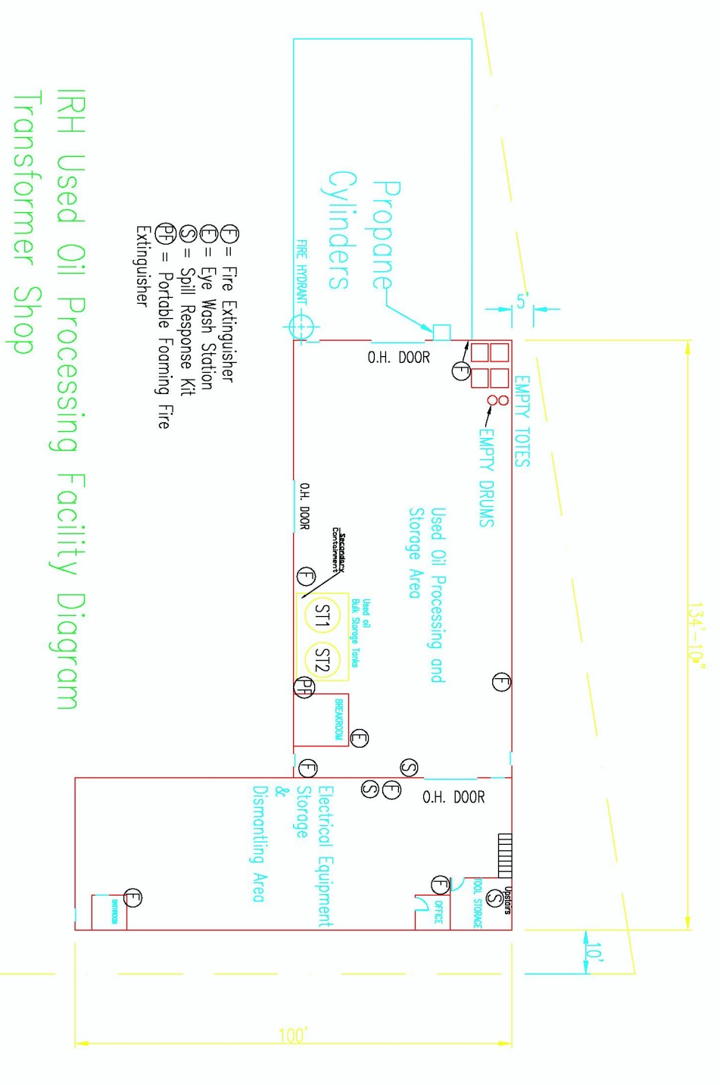
Attachment 1
Figure 1: Facility Diagram and Location of Emergency Equipment

Attachment 1 - Appendix 1
Inspection Form for Storage and Handling Areas

IRH Facility
Used Oil Storage and Handling Areas
(Bi-Monthly)*
Equipment | Inspection Elements |  | Status |  | If “Not OK” State Reason | Date Corrected  (Initials)
 |  |  | OK | Not  OK
Tanks and Tankers (if applicable) | - Check tanks for signs of deterioration  - Check auxiliary tank valves, pumps and piping  - Check that tanks and piping is properly labeled  - Check secondary containment for leaks or signs of deterioration  - Check for oil in secondary containment area
Containers (e.g. Drum and Totes) | - Check containers are closed and not leaking  - Check that containers are properly labeled
Transformer Dismantling Area | - Check metal secondary containment for leaks or deterioration  - Check for oil in secondary containment area
Comments:
Inspection Date:_______________ |  | Inspector’s Signature:_____________________________
* IRH will inspect the unit weekly until the deficiency has been corrected.
Attachment 1 – Appendix 2
Inspection Form for Safety/Emergency Equipment

IRH Facility
Safety/Emergency Equipment Inspection Form
(Bi-Monthly)*
Equipment | Inspection Elements |  | Status |  | If “Not OK” State Reason | Date Corrected  (Initials)
 |  |  | OK | Not  OK
Spill Kits/First Aid Kits | - Inventory sheet with spill kit/First Aid Kit.  - Check for presence of all listed supplies.
Eye wash/Showers | - Check operational status.  - Check for damage or deterioration.
Fire extinguishers | - Check tags for expiration dates.  - Check pressure gauges for adequate pressure.
Communication System | - Check communication systems are in place.
Comments:
Inspection Date:______________ |  | Inspector’s Signature:_______________________________
* IRH will inspect the unit weekly until the deficiency has been corrected.

Attachment 2
IRH Emergency Control and Contingency Plan
- Introduction
This Emergency Control and Contingency Plan is designed in accordance with the requirements of the Utah Administrative Code R315-15.5 to implement a contingency plan and emergency procedures including the appropriate equipment required to minimize hazards to human health or the environment from fires, explosions, or any unplanned sudden or non-sudden release of used oil to air, soil, or surface water. This plan also establishes activities required of IRH personnel to carry out to mitigate such discharges (i.e., countermeasures) should they occur.
- Facility Description and Operations
The IRH purchases used electrical equipment for recycle. Used transformer oil generated at the facility from transformer dismantling operations or is received from used oil transporters. The used oil is stored in drums, totes or tanks. Secondary containment is provided in storage areas via basins, pans, berms and curbing, and absorbent materials. In addition, IRH facility stores and processes electrical equipment regulated under CFR 40 § 761.
- Site Security
The Salt Lake City facility operates during normal business hours. A chain-link fence surrounds the area that includes all of the facility’s structures. At night, the facility's operational areas are lit. Access to the facility is restricted to employees, contractors, vendors and authorized visitors. Storage tanks are located inside the facility’s secured building structures.
- Commitment of Manpower and Resources
The facility shall have an emergency coordinator at the facility or on call that is available to respond to a facility emergency within a short period of time (Table 1). The primary and secondary emergency coordinators are listed in Table 1 below. The emergency coordinators shall be thoroughly familiar with all aspects of the facility’s emergency control and contingency plan, facility operations, and have the authority to commit the resources needed to carry out the contingency plan. In their absence, all facility and office personnel will evacuate, and the most senior employee will contact the emergency coordinators and call IRH Corporate at 801-972-5581.
Table 1: Facility Emergency Coordinators and Contact Information
Emergency Coordinators | Title | Contact Information
Chris Johnson | Operations Manager  (Incident Commander) | Office Phone: 801-972-5581  Cell Phone: 801-910-7162
Jim Haslam | HSE Manager  (Incident Commander) | Office Phone: 801-972-5581  Cell Phone: 801-831-6024

- Facility Emergency Equipment
The facility is equipped with the emergency equipment listed in Table 2. All emergency equipment is inspected and maintained as necessary to assure its proper operation in time of emergency.
Table 2 – List of Facility Emergency Equipment
Physical Description | Location | Capabilities/Intended Use
Spill Control Equipment | Transformer Shop | Secondary spill containment
Absorbent materials | Transformer Shop | Spill clean-up
Fire extinguishers | Throughout Property, wall-mounted, Transformer Shop | Extinguish fires, dry chemical type
Foam suppression systems | Transformer Shop | Extinguish fires
Fork lifts and yard tractor with fire extinguishers | Throughout Property and Transformer Shop | Hauling, fire control
First aid kit | Office / Transformer Shop | Treat minor injuries
Tools | Warehouse | Various repairs
Recovery drum | Warehouse | Secondary Containment
Eye wash stations | Office, shop, unloading / loading area / Transformer Shop | Employee safety from chemical splashes
Safety showers | Office | Employee safety from chemical splashes
Safety and warning signs | Throughout property, Transformer Shop | Employee safety
Hard hats, safety glasses, goggles, and face shields | Office, Throughout Property | Protection handling
Chemically resistant gloves, boots, rain suit, apron | Property office / Transformer Shop | Protection
Communications system | Cellular Telephones | Emergency Calls
Decontamination Equipment | Transformer Shop | Clean Spills
6.0 Communication
In the event of an emergency or used oil spill, the employee will contact the supervisors and emergency coordinators within the facility, immediate verbal communication should occur between witnessing the spill and IRH management.
7.0 Facility Emergency Evacuation Plan
In the event of a serious spill, fire, or explosion which presents possible hazards to human health and to the environment, all personnel will immediately evacuate the premises in accordance with the following procedures.
Cell phones will be used to alert employees of the emergency and an employee shall be assigned to check the offices (bathrooms) and warehouses to assure all employees have evacuated the area.
Employees shall muster at the parking lot directly across Central Avenue (850 South) for further instructions.
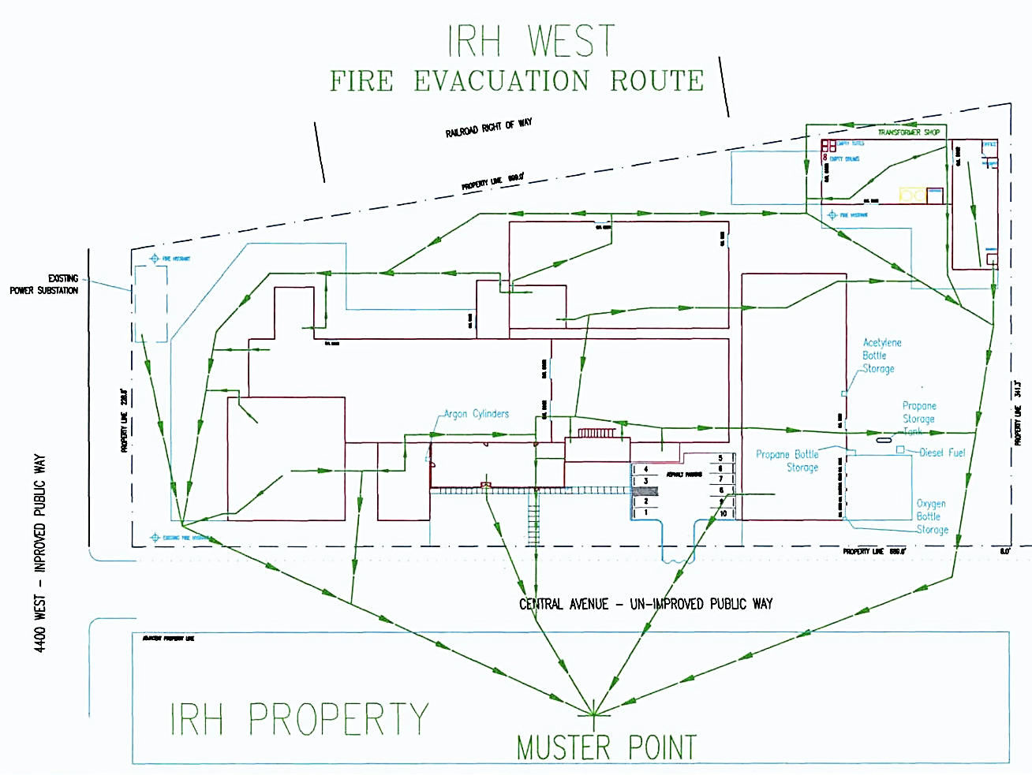
Figure 7.1: Emergency Evacuation Route Diagram

8.0 Coordination Agreements
8.1. A copy of the emergency spill and contingency plan will be maintained onsite and has been submitted to the emergency response agencies listed in Table 8.1.
Table 8.1: Emergency Response Agencies that RH’s submitted Spill and Contingency Plans
Emergency Response Agency | Address | Contact Information
Salt Lake City Fire Department Station 7 | 273 North 1000 West, Salt Lake City, UT 84116 | Phone: (801) 799-4103
Salt Lake City Pioneer Police Precinct | 1040 West 700 South, Salt Lake City, UT 84104 | Phone: (801) 799-4600
LDS Hospital | 8th Ave N & C Street, Salt Lake City, UT 84143 | Phone: (801) 408-1100

9.0 Spill Control, Emergency Response and Reporting Requirements
9.1. Intermountain Rigging and Heavyhaul (IRH) shall immediately cleanup any spill which occurs during the loading/unloading or processing of used oil at the facility.
9.2. The operator shall call 911 when warranted to summon emergency personnel to the scene.
9.3. The operator shall take action to prevent the spilled material from spreading by utilizing absorbent, dirt, booms, pads, rags, etc. The operator should prevent used oil from entering any adjacent storm water drain, sewer drain system or leaving the facility boundary.
9.4. In the event that more resources are required, the operator will contact a supervisor to dispatch a spill response team to help facilitate the mitigation and/or remediation of the spill (Table 9.1).
9.5. Used Oil spills exceeding 25 gallons, or smaller quantities that pose a risk to human health and the environment, shall be reported to IRH’s management, to the Utah Department of Environmental Quality. and to the National Response Center at 1-800-424-8802, if required by 40 CFR part 110 or 112, the discharge of used oil from the facility that impacts any navigable waters or adjoining shorelines (Table 9.2).
9.6. IRH operators shall submit a completed spill report to a supervisor at or before the end of the operator’s shift (Attachment 2, Appendix 1). The report must follow the reporting requirements of R315-15 and IRH’s Processor Permit.
9.7. IRH’s employees shall report any spills to management, regardless of the volume. Employees are exempted from reporting de minimis drips to management that are immediately cleaned up responsible employee.

Table: 9.1: Emergency Contacts List (Company Personnel)
Contact Person | Title | Contact Information
Chris Johnson | Facility Manager | Mobile: (801) 910-7162  Office: (801) 972-5581  Email: chris@irhusa.com
Jim Haslam | Safety Manager | Mobile: (801) 831-6024  Office: (801) 972-5581  Email: jim@irhusa.com
Salt Lake City Fire Response  (In case of fire or injury) | NA | 911
IRH  Saftey-Kleen | Response/Cleanup  Response/Cleanup Contractor | Office: (801) 972-5581  Office: (801) 972-0742

Table: 9.2: List of Agencies to Notify in Case of a Spill Exceeding 25 Gallons

Agency Notification | Contact Phone Number
National Response Center (if required by 49 CFR 110 or 112) | (800) 424-8802
Utah Department of Environmental Quality (within 24 hrs.) | (801) 536-4123

Attachment 2 – Appendix 1: IRH Spill Report Form
Part A: Discharge Information |  | Name of Employee Reporting Spill:
General information when reporting spill to outside agencies  Name: Intermountain Rigging and Heavyhaul  Address: 850 South 4340 West, Salt Lake City, Utah  Telephone: (801) 627-7273  Owner/Operator: Steven Knight - Owner  961 South Pioneer Road  Salt Lake City, Utah 84124  Primary Contact: Chris Johnson Facility Manager  Work: (801) 972-5581  Cell (24 hrs.): (801) 910-7162 |  | Type of oil: |  | Discovery date and time:
 |  | Total quantity released: |  | Discharge date and time:
 |  | Location/Source: |  | Affected media:  Soil  Surface Waters  Storm Drain  Sewer/POTW  Other
Nature of discharges, environmental/health effects, and damages:
Actions taken to stop, remove, and mitigate impacts of the discharge:
Part B: Notification Log
Discharges of any Amount | Date and Time |  | Name of Person Receiving the Call
Chris Johnson – Operations Manager
Work: (801) 972-5581
Cell (24 hrs.): (801) 910-7162
Discharges Exceeding 25 gallons | Date and Time |  | Name of Person Receiving the Call
Utah Department of Environmental Quality
(801) 536-4123
Salt Lake City Fire Department/Other When Applicable 911
Other Notification Information:

Attachment 3
IRH Facility Closure Plan
- General Requirements
1.1. The used oil processing facility operated by IRH will be closed in a manner that minimizes the need for further maintenance and eliminates, minimizes, or controls the possible hazards to human health and the environment in accordance with the Permit (UOP-0157) and this closure plan.
1.2. Prior to closure this plan will be modified by IRH to add detailed procedures for sampling and decontamination or removal of all contaminated soil, groundwater and equipment. The closure information and estimated clean up and closure costs required by R315-15-12 in this document is general and are based on current information and future estimates of the use, current inventory and potential contamination and remediation of IRH’s use oil processing facility. Estimated clean up and closure costs for financial assurance are itemized Attachment 3 (Appendix 1).
1.3. The updated sampling and analysis plan shall be submitted to the Director of the Division of Waste Management and Radiation Control (DWMRC) for review and approval prior to implementation.
1.4. Throughout closure of the facility, all operations will be performed in a manner that will protect personnel, human health, and the environment. The necessary level of protection will be achieved by ensuring that various precautions are put in place and properly implemented. Precautions will include:
1.4.1. Security: All existing security (e.g., signs, gates) will be maintained and, as necessary, supplemented.
1.4.2. Inspections: The facility inspection program will inspect areas where hazardous waste and residues are temporarily stored during remediation and decontamination.
1.4.3. Personnel Training: All personnel associated with facility closure will receive the training necessary to perform their duties.
1.4.4. Preparedness and Prevention: During closure activities, all equipment necessary to respond to potential emergencies at the facility will remain available. The facility will be maintained in such a manner as to minimize the potential for emergencies during closure.
1.4.5. Contingency Plan and Emergency Procedures: The facility Emergency Control and Contingency Plan (Attachment 2) will be maintained, and, as necessary, augmented to describe proper responses in the event of emergencies during closure.
2.0 Used Oil Inventory Removal
2.1. A representative sample will be collected for chemical analysis of the used oil remaining at the facility at time of closure. The sample(s) shall be the type of sample containers, sample preservation requirements, maximum holding times for each method, constituents analyzed, preparatory and analytical methods shall be specified in the updated closure plan approved by the Director at closure of the facility.
2.2. IRH shall send all used oil to a thermal treatment facility (incineration) for disposal unless the Director approves and alternate disposal method at time of closure.
3.0 Used Oil Storage/Processing Areas and Equipment
3.1. IRH shall inspect slab areas, tanks, ancillary processing equipment, liquid transfer lines, sump structures and secondary containment areas for evidence of past or present release of contaminants to the environment and document the findings. IRH will remove any accumulated materials (e.g. dust, dirt, etc.) that would inhibit recognition of spills or releases before the inspection process.
3.2. IRH shall identify and record the location of damage which could have caused the loss of integrity of the containment system after decontamination of the containment surfaces.
3.3. IRH shall repair any cracks or other damage to containment surfaces to assure that spilled rinsate water generated from cleanup operations or oil spilled during removal operations does not contaminate ground/groundwater during decontamination efforts.
3.4. Tanks and ancillary equipment shall be decontaminated and rinsate and clean up materials generated during closure activities will be properly characterized and transported to the appropriate hazardous or solid waste facility, as applicable.
3.5. At time of the closure of the facility, the Permittee shall sample the soil and groundwater to determine potential contamination from operational activities. At a minimum, core sampling (4) (through concrete) will be conducted to collect soil (0-2 feet) and a shallow groundwater sample beneath the used oil tanks, the used oil container (tote) storage area (north west corner of processing facility) and the used oil truck loading and unloading areas (Attachment 6, Appendix 1). The sample locations may be relocated (Director approval is required) to areas in facility where there are cracks, holes or staining indicating potential leakage of used oil to the ground.
3.5.1. The sample(s) shall be the type of sample containers, sample preservation requirements, maximum holding times for each method, constituents analyzed, preparatory and analytical methods shall be specified in the updated closure plan approved by the Director at closure of the facility.
3.5.2. The Permittee shall submit a Level IV data validation analytical package from a Utah- certified laboratory, within 30 days of receipt, to the Director for review and approval.
4.0 Facility Closure Certification
Closure of the facility in accordance with requirements of this Permit and closure plan shall be verified by a Utah certified independent Professional Engineer (P.E.), reviewed, and approved by the Director.

Attachment 3 – Appendix 1
Itemized Task Clean up and Closure Costs for Financial Assurance

Description | Item Amount | Rate | Cost
Plant Decommission: Removal of Used Oil Inventory and Other Wastes
Used Oil removal / incineration | 19,900 gallons | $0.70/gal | $13,930.00
Used Oil Removal & Transportation Costs | 3 loads | $300.00/Tanker Load | $900.00
Tank Decontamination & Rinsate Disposal | 2 tanks  2 Vehicle Tanker | $1800.00/tank  $800.00/Vehicle Tanker | $5,200.00
Disposal Used Oil Containers | 10 containers | $80.00/container | $800.00
Scrap Metal Disposal (Transformers) | 10,000 lbs. | $0.25/lb. | $2,500.00
Site Clean Up Waste (soil) Disposal | 1 truck load | $2,000.00/truck load | $2,000.00
Misc. Oversight Labor Costs | 75 hours | $100.00/hour | $7,500.00
Facility Soil and Water Investigation
Sampling (Soil & Water) | 8 samples | $150.00/sample | $1,200.00
Sampling Rig Mobilization | 1 mobilization | $1,200.00/mobilization | $1,200.00
Laboratory Analytical Cost | 8 samples | $1,200.00/sample | $9,600.00
Final Closure Verification Costs
Independent P.E. Verification of Closure | 1 certification | $2,500.00/certification | $2,500.00
Division of Waste Management Review | 30 hours | $100.00/hour | $3,000.00
Total Closure Cost Estimate: $50,330.00

Attachment 4
IRH Employee Used Oil Training Plan
- Employees must be instructed on the handling of used oil, the operation and maintenance of used oil processing equipment, analytical methods and sampling procedures, the appropriate use of generator knowledge to determine halogen content of used oil in lieu of analytical testing and the facility’s Emergency Control and Contingency plan. The training should include resources available for spill response, proper waste disposal, and emergency communication procedures.
- Employees who are trained in accordance with the plan shall receive annual refresher training of sufficient content and duration to maintain their competencies.
- The facility’s health and safety manager or operations manager will maintain a written description of training activities and generate a training record for each employee to document employee training.
4.0. New employees will be trained within 30 days of employment. Untrained employees will not be allowed to conduct used oil processing operations without the presence of a trained employee until training is completed.
5.0. Used oil trainers who teach any of the above training subjects shall have satisfactorily completed a training course for teaching the subjects they are expected to teach, such as the courses offered by the U.S. National Fire Academy, or they shall have the training and/or academic credentials and instructional experience necessary to demonstrate competent instructional skills and a good command of the subject matter of the courses they are to teach.

Attachment 5
IRH Facility Process and Instrument Diagrams A102
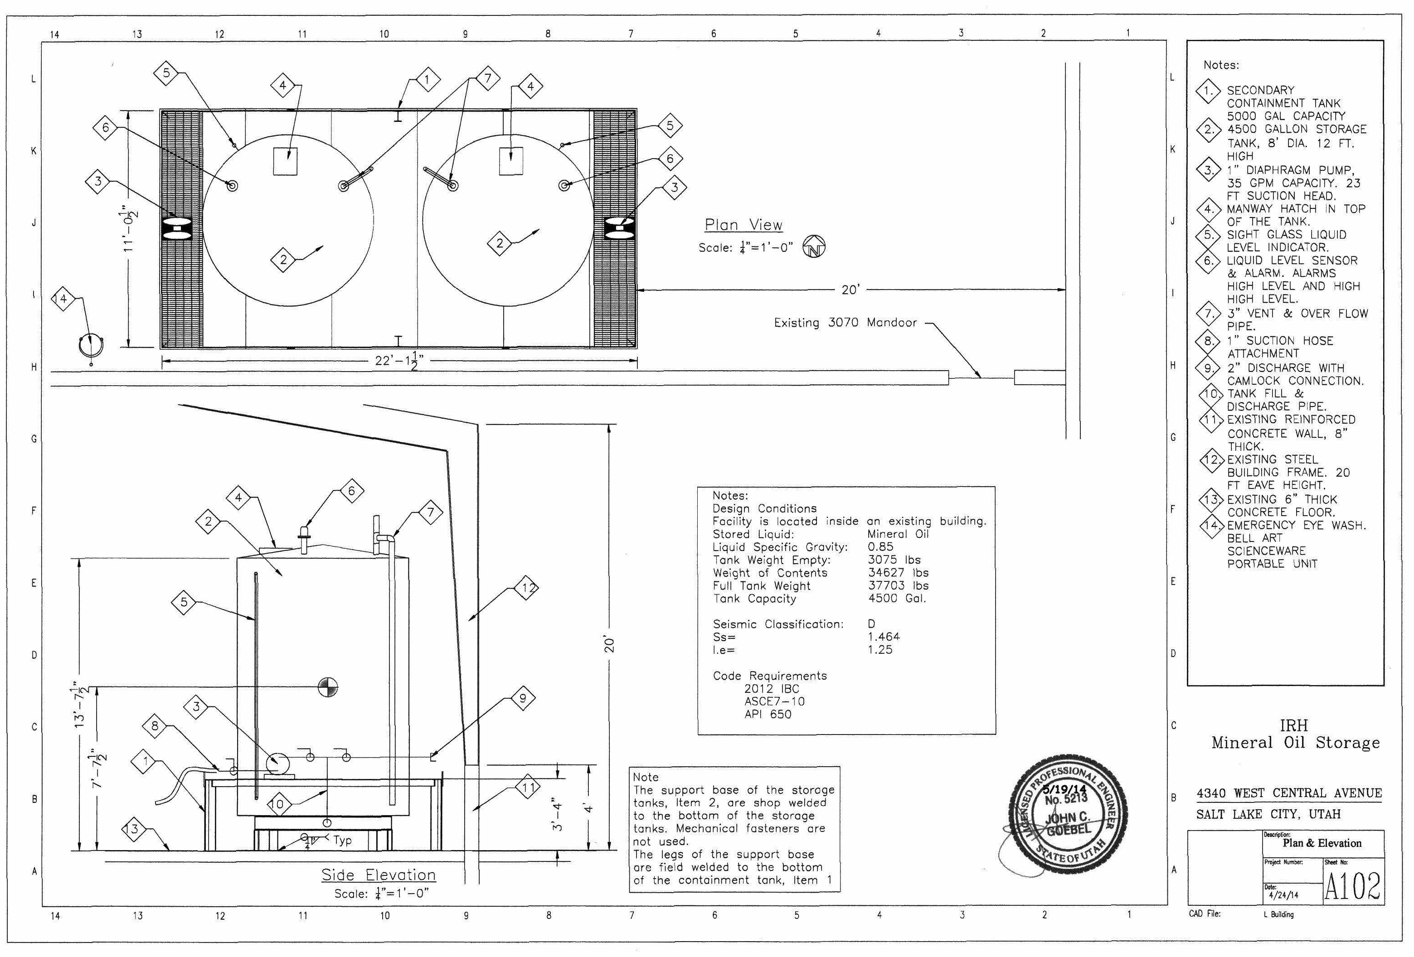

Attachment 5
IRH Facility Process and Instrument Diagrams A103
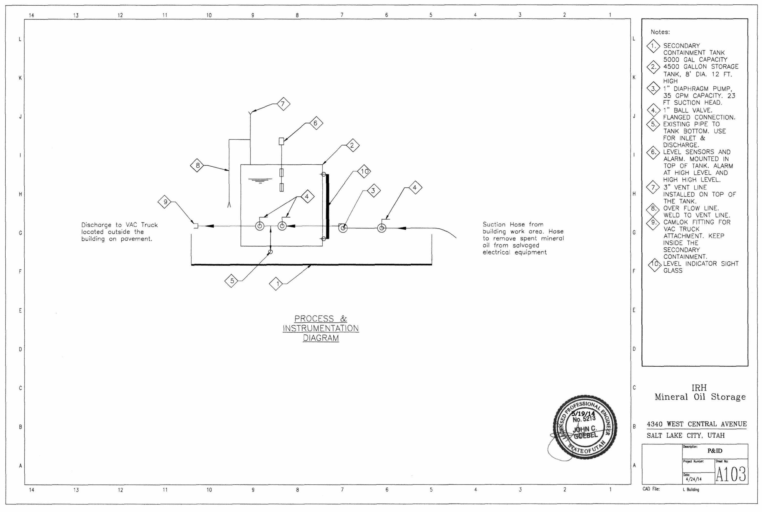

Attachment 6
IRH Standard Operating Procedure - UO-1
Used Oil Vehicle Loading and Unloading Operations

Standard operating procedures (SOP) UO-1 addresses the loading and unloading of used oil at the facility. Vehicles may be unloaded or loaded in two areas. Vehicles will be parked adjacent to the overhead door on the southern wall (exterior) of the used oil processing and storage area in the transformer shop (Attachment 6 - Appendix 1- Loading Areas) or vehicles will drive into the used oil processing and storage area in the transformer shop (overhead door west wall) to unload or load used oil. During loading and unloading operations, a trained operator shall remain at the transfer location and maintain control of the operations throughout the entire used oil transfer. Berms are in place across the thresholds of the transformer shop doors to contain any used oil spilled inside of the transformer shop while transferring oil. A portable secondary containment system will be deployed to contain potential oils spills while loading and unloading trucks that are adjacent to the overhead door of the southern exterior wall of the transformer shop.

Procedures
Operators shall secure the vehicle by positioning wheels chocks, place a warning sign and applying the emergency brakes before loading or unloading used oil from vehicles.

The operator shall inspect valves and hoses on tanker trucks/used oil tank for leaks and if necessary tightened, adjust, or replace if leaks are found.

The operator shall ensure the amount of used oil to be loaded into the transport vehicle will not exceed the carrying capacity.

Operators shall inspect used oil containers for leaks before loading or unloading vehicles with a fork lift.

The operator shall clean up any spills of used oil in accordance with IRH’s emergency controls and contingency plan.

The operator shall assure that shipping paperwork is completed correctly and placed in the facilities records.

Attachment 6 - Appendix 1
Location of Vehicle Loading and Unloading Areas
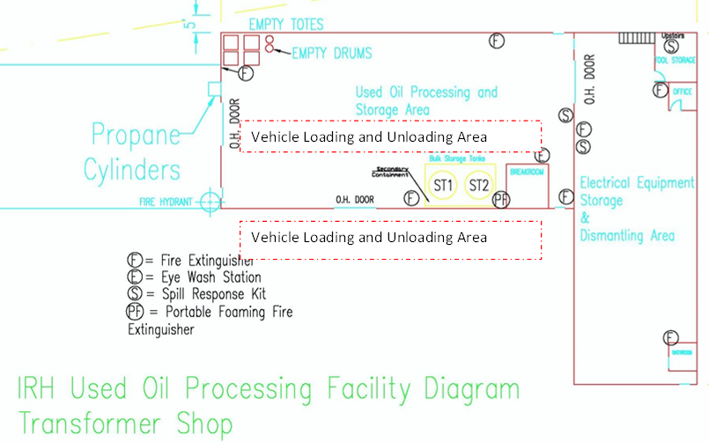

Attachment 7
Used Oil Sampling Procedures
Required Equipment
COLIWASA Sampling Device: Glass/Polypropylene/ plastic type tube or “tank” sampler.

Tank ST1 and ST2 Lock Down Procedures
All outgoing oil shall be tested for PCB’s before leaving the facility.
Step 1:
The operator shall “lock down” the tank/container valve so that used oil cannot be added or removed from the tank/container. The operator shall record the time the tank/container was locked down and volume of used oil in the facility’s operating record. A representative sample will be collected from the tank and sent to a Utah certified laboratory for analysis
Step 2:
The operator may remove the lock on the tank after review of the sample analytical results and pump the oil from the tank into a used oil transportation vehicle for delivery to the customer. The operator shall record the time the lock was removed and the volume of oil removed from the tank in the operating record.
Container Sampling Procedure
Step 1:
Lower the COLIWASA slowly into the used oil at a rate that allows the liquid level inside and outside the tube to equalize.
Step 2:
Slowly withdraw COLIWASA from the liquid. Either wipe the exterior of the sampler tube with a disposable cloth or allow excess liquid to drain back into the used oil tank.
Step 3:
Discharge the entire sample by placing the lower end of the COLIWASA into a sampling container.
Step 4:
Homogenize the sample. Fill a labeled sample jar and send to a Utah certified laboratory for analysis.
Step 5:
Empty the remaining oil in the sampling container back into the used oil tank.

